SDG GitHub Repository

Quick user guide

Table of contents

1. Introduction 3

2. Getting started 3

2.1. Create an account in GitHub 3

2.2. Download GitHub desktop 3

2.3. Download Git 3

2.4. Create a new repository 3

3. Integrating GitHub and RStudio 3

3.1. Create a new project in R Studio 3

3.2. Create a SSH RSA key 4

4. Working simultaneously with RStudio and GitHub 4

4.1. Create and save a new script within the current project 5

4.2. Create a new branch 5

4.3. Commit and push your changes 5

4.4. Create a pull request 5

4.5. Merge a pull request 6

5. Uploading and synchronising files 6

5.1. Move your file 6

5.2. Synchronise your file 7

1. Introduction

The aim of this document is to offer a step-by-step guide to quickly get started with GitHub and its integration with RStudio. GitHub is the most popular code hosting platform for version control and collaboration. GitHub allows to track changes when multiple people collaborate on a project. This platform can also be integrated with other tools, such as RStudio. RStudio provides an interface for version control using Git. When working with Git, it is important to differentiate between the remote repository, which is essentially the web version of GitHub and the local repository, which is the repository that is stored on the computers of various team members and that can also be visible in the desktop version of GitHub.

1. Getting started
   1. Create an account in GitHub

The first thing to do is to create an GitHub account in the main [website](https://github.com/) of this platform. Please not that a GitHub account is required to collaboratively work in a repository.

* 1. Download GitHub desktop

The desktop version allows to update the remote repository when adding files in the local repository. The GitHub desktop version can be downloaded [here](https://desktop.github.com/).

* 1. Download Git

Download Git to connect GitHub with RStudio. Git can be downloaded [here](http://git-scm.com/).

* 1. Create a new repository

Once you have created your GitHub account, you can create a repository in the web version of GitHub. In a GitHub repository, a variety of projects and files can be stored either to collaborate with others or to make their content available to a larger audience. A step-by-step guide to create a repository can be found [here](https://docs.github.com/es/get-started/quickstart/create-a-repo). Please note that it is considered a good practice to add README.me file to describe the project and the files that are stored in the repository.

1. Integrating GitHub and RStudio
   1. Create a new project in R Studio

Choose ‘File’ > ‘New project’ and then choose ‘Version Control’ > ‘Git’. In the Repository URL paste the link of the repository. To copy the link of the repository, go the web version, select the repository and then click on the green button ‘Code’ and copy the HTTPS link. Afterwards, choose a folder in which you want to save your local repository by clicking on the Browse button (this will automatically create a clone folder, that will be visible in the desktop version of GitHub). Lastly, click on ‘Create Project’.

|  |  |
| --- | --- |
|  |  |
|  |  |

* 1. Create a SSH RSA key

In RStudio go to ‘Tools’ > ‘Global Options’ > ‘SSH and GPG keys’ and click on ‘Create RSA key’ and then ‘Create’ (no need to set a passphrase) and copy the key. Afterwards, in the web version of GitHub go to ‘Account settings’ > ‘SSH and GPG Keys’, copy the Key, add a title (e.g., RStudio) and click on ‘Add SSH key’.

|  |  |
| --- | --- |
|  |  |

1. Working simultaneously with RStudio and GitHub

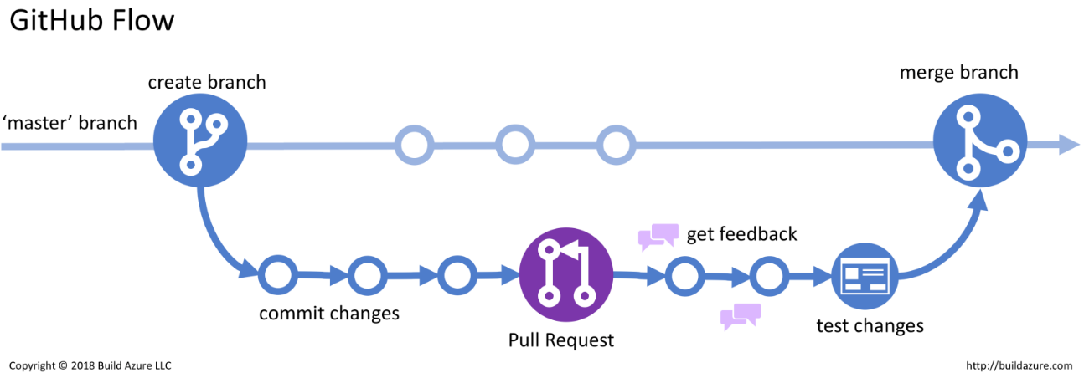When team members need to work individually in an R script, they need to create new branches in order to avoid unwanted modifications of the master branch. When changes are made in new branches, they need to be committed and pushed in order to create a pull request, so that they can be merged with the master branch. The diagram bellow shows a simplified workflow of the branching system of GitHub. The following steps illustrate the main processes of such workflow.

* 1. Create and save a new script within the current project

Script files that are created within the current project can be saved in the folder that was automatically created in step 3.2. To save the script, it is necessary to give a name to the file and either press the ‘Save’ button or go the ‘File’ menu and choose ‘Save’.

* 1. Create a new branch

When a script file needs to be modified, it is recommended to create a new branch in order to avoid unwanted changes in the master branch. When you create a branch off the master branch, you are making a copy, or snapshot, of master as it was at that point in time. To create a new branch, press the ‘New Branch’ button located in the Git panel. When the new branch is created, its name will appear on the top-left side of the RStudio window.

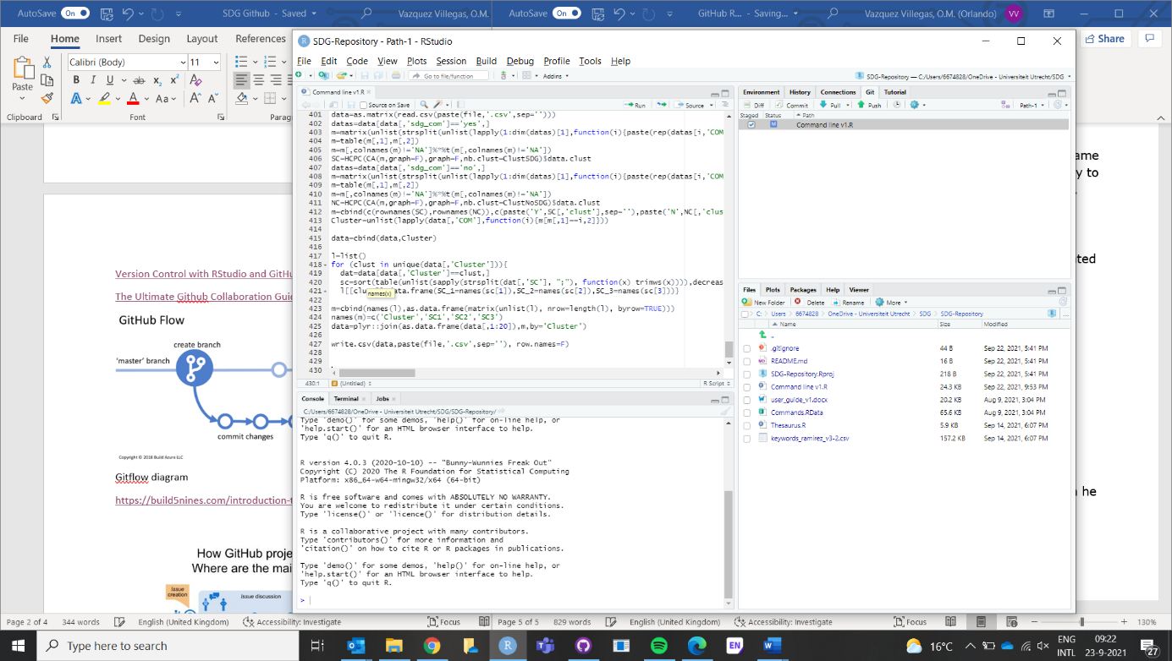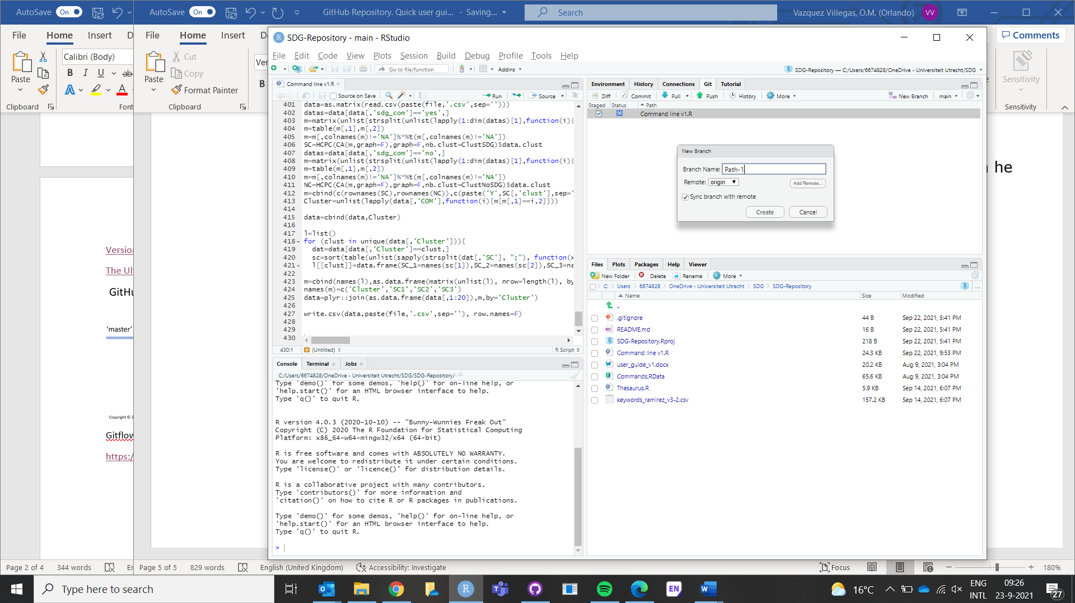

* 1. Commit and push your changes

Having made any changes in the script file, you need to save your script and the changes will be listed in the Git panel. In order to commit those changes, click on the ‘Commit’ button and a new window will pop up with the new changes. Write any comment related to the new changes and click on the ‘Commit’ button again. In order to make this change visible in the desktop version of GitHub, click on the ‘Push’ button.

|  |  |
| --- | --- |
|  |  |

* 1. Create a pull request

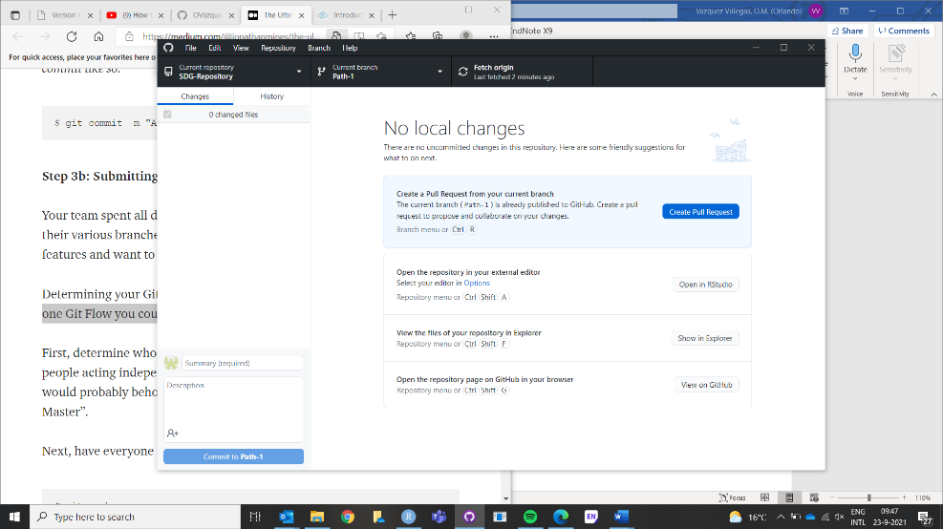Once the changes have been pushed, they will be visible in the desktop version of GitHub. There you must click on the button ‘Create a Pull Request’. In doing so, the person in charge of handling merging will be able to see your pull request and either approve it or rejected it.

* 1. Merge a pull request

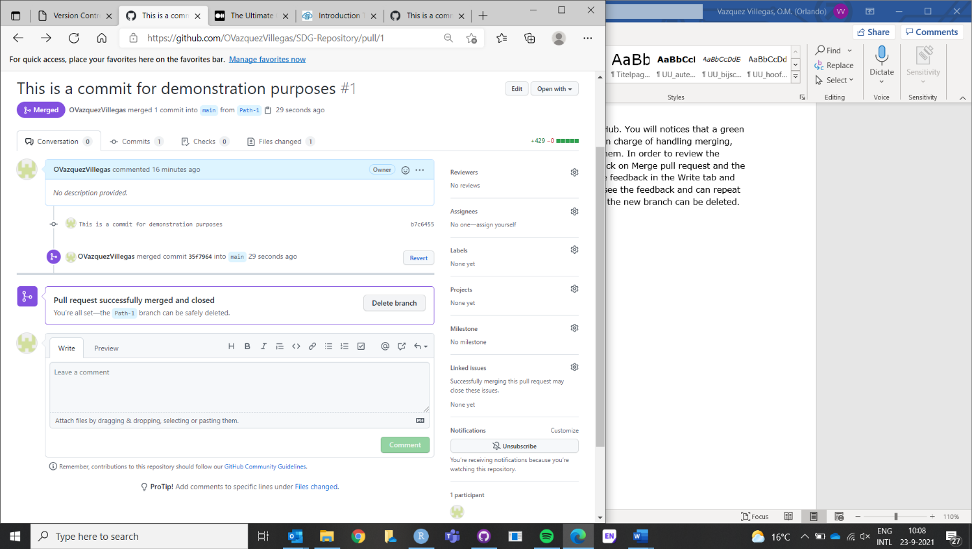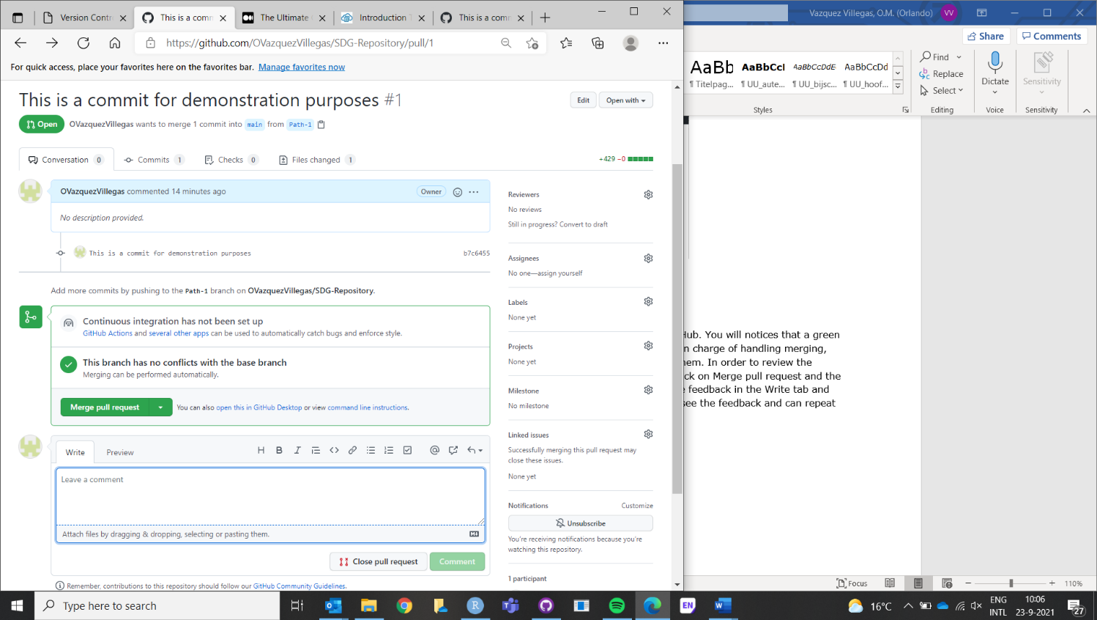Now go back to your remote repository in the web version of GitHub. You will notice that a green button saying ‘Compare & pull request’ appears. Here the person in charge of handling merging, needs to check the changes, and either approve them or reject them. In order to review the changes, click on the ‘Files’ changed tab. If the changes are ok, click on ‘Merge pull request’ and the click on ‘Confirm merge’. If you cannot approve the changes, provide feedback in the ‘Write’ tab and click on ‘Comment’. Then, the person that made the changes can see the feedback and repeat steps 4.3 and 4.4. When the pull request has been merged, the new branch can be deleted.

1. Uploading and synchronising files
   1. Upload your file

When new files (no RStudio files) need to be stored in the repository, they can be added directly to the local repository (the local folder that was originally created in step 3.1).

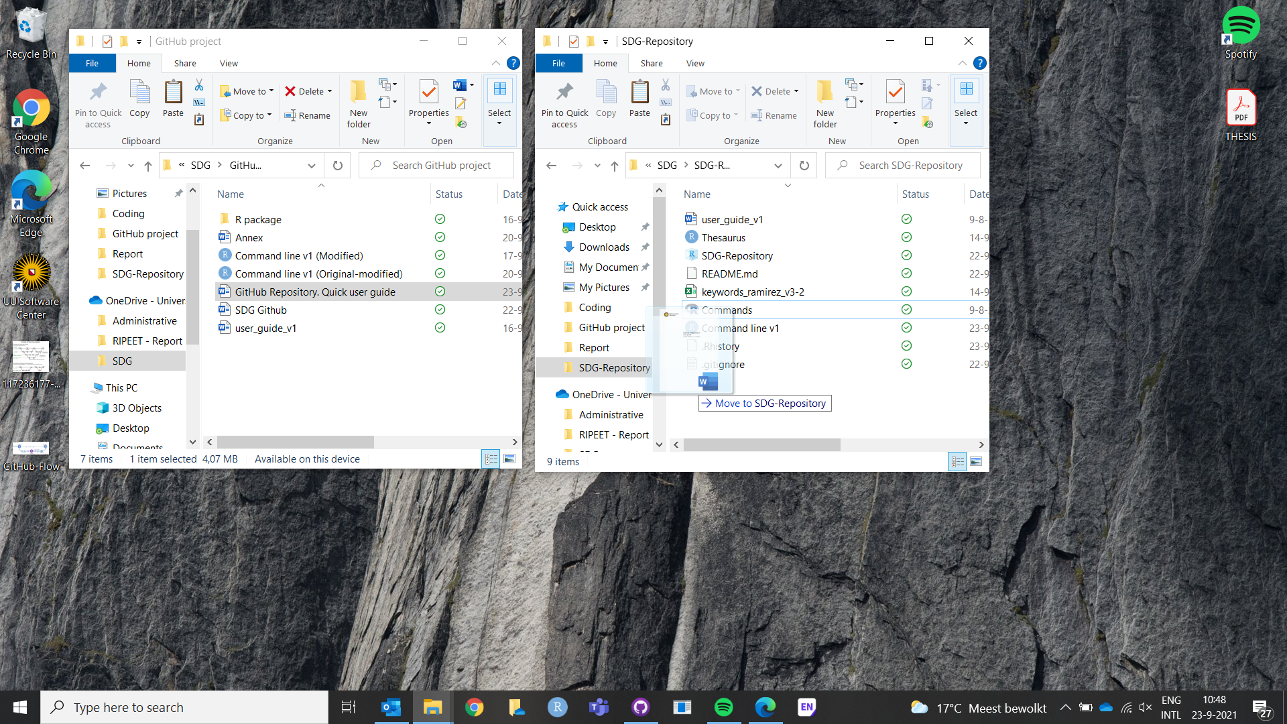

* 1. Synchronise your file

Once the file has been upload to your local repository, open the desktop version of GitHub. There, you will notice that a message saying ‘1 changed file’ appears in the left top corner. Click on ‘Commit to main’ and add a comment, so that the file can be available in the remote repository. When a change is made in a file (e.g., a Word document), GitHub Desktop will automatically detect such change and it must be committed again to update the file in the remote repository.

